Section 1: Business Need and Importance
Baseball is a sport with one of the shortest career lengths yet players who emerge as superstars have commanded some of the largest sporting contracts in history. These mega contracts unfortunately price many teams out of signing superstars, so some teams have looked to take a risk on a player not at their peak in exchange for a team friendly contract if they plan out. The timing of these extensions is crucial as waiting only a single season can save a team millions of dollars. The gold standard of an early extension is when the Atlanta Braves signed Ronald Acuna Jr. to a 100-million-dollar extension at the start of the 2019 season, Acuna’s sophomore season [1]. Waiting one additional season cost the San Diego Padres an extra 240 million in comparison to Acuna’s contract, as Fernando Tatis Jr. put together his second strong campaign in the same amount of years [1, 2]. Both of their respective seasons can be considered “breakouts”, where they sustain a drastic improvement compared to the previous season and truly establish themselves as stars. Baseball teams around the world can save millions of dollars by identifying breakout players before they happen. The NPB (Nippon Professional Baseball) is one such league that can benefit due to its’ rapid growth, with yearly attendance increasing by over 25% since 2013, when Shohei Ohtani made his debut [2, 3]. Teams aren’t the only group who stand to benefit from breakout identification. Agents can use an upcoming breakout as leverage in early contract extension negotiations to put pressure on teams to offer millions more in fear of what happened to the Padres with Tatis Jr.
Section 2: Statistical Methodology
The data for this analysis comes from https://proeyekyuu.com [4]. This website contains season statistic logs dating back to 1936, and game play-by-plays (PBP) dating back to 2016. An overview of the website and a data snippet can be seen in Appendix 1. While the season statistic logs had every common baseball statistic, there was no standardized performance metric in comparison to the whole league. A metric called “Weighted Runs Created” (wRC) can be used to facilitate these comparisons. Fangraphs defines wRC as a way to “measure a batter’s value using cumulative statistics that credits a player for total production rather than on an at bat by at bat basis.” [5]. wRC was calculated in reference to Fangraphs using the PBP data. A preview of PBP data can be seen in Appendix 2. A variable called ServiceTime was created to replace the absence of player age. ServiceTime identifies how many seasons one played in the NPB, shown in Appendix 3. All full season data before 2016 was removed to be in line with the PBP data. Postseason data was removed due to not all teams making the playoffs. [5, 6, 7, 8, 9]. Players who played for multiple teams in a season were consolidated into one row based on their name, season, and PlayerID. All players with zero accrued statistics were also removed along with pitchers. Players were eligible for breakouts years 2 through 5 of ServiceTime. A breakout was defined as any player who had a wRC above 80 and an improvement of over 60 from the previous year. These thresholds restrict breakouts to players early in their NPB career who have had exposure to playing at the top level. 28 players were identified as Breakouts, and the season before was marked as PreBreakout as the identifier for a breakout to occur in the following season. A Pearson’s correlation was run on the data, and multiple columns were removed. shown in Appendix 4.
After the identification of PreBreakouts, there was a large imbalance with PreBreakouts after defining them. Positive instances of PreBreakout accounted for under 3% of the cleaned dataset. This imbalance would encourage the model to never predict a PreBreakout. A classification tree was used to remedy this by subsetting the data using a system of greater than and less than thresholds. The leaves were then inspected for pure subsets. Any pure subsets of class zero signifying no PreBreakout were removed from the dataset. After the classification tree data was ran, the data was split into training and testing at a 70/30 ratio respectively. A scaling model was then made using the preprocess function from caret on the training set and subsequently applied to the training, testing, and 2025 datasets. Names were re-appended to the 2025 dataset to maintain its purpose as the validation set. There was still a heavy imbalance after the classification tree. The ROSE (Random Over-Sampling Examples) package in R was used to generate balance into the training dataset. Lunardon et. al. define ROSE as a “bootstrap-based technique which aids the task of binary classification in the presence of rare classes. It handles both continuous and categorical data by generating synthetic examples from a conditional density estimate of the two classes” [6]. ROSE was used to increase the number of data points to 1500 at a 40% positive rate. Appendix 5 showcases the steps to balance the data.
Because PreBreakout is a classification variable based off all other statistics in the dataset, the use of K-Nearest Neighbors (KNN) is warranted. KNN uses a noted distance between data points to identify which are most similar, their “nearest neighbors. This is less computationally expensive than another classification tree. Naïve Bayes was not needed as no new information was being added to influence a prior probability. The KNN model was tested on multiple K, weight, and distance values with 5-fold cross validation to search for the highest precision, which is the accuracy rate of predicted positives. The optimal model used K=27, Manhattan distance, and the biweight kernel [7, 8]. This can be seen in Appendix 6.
Section 3: Results and Interpretation
Two predictions were run using the testing set with the newly optimized KNN model. One model was purely about classifying yes or no. With splitting the classes into half this model performed poorly. It returned a precision of only 5% when put against the testing data. Over 35% of the observations were predicted to be breakouts. When taking into consideration the overall accuracy of 65% and a precision of 5%, this model might as well have been guessing if there was a breakout. The second model utilized probability, and a 90% cutoff was imposed to enforce the benefit of being right. It is better to mark a positive as a negative rather than predict a negative as a positive. When millions of dollars are on the line, the organization writing the check will want to be sure that they’re making a correct decision. The rate of predicted breakouts fell to 2.5% in this new cutoff. This is more realistic to the case at hand. The accuracy rose to 96%, and specificity increased by over 30% up to 98%. Precision however only rose to 28%. The high specificity explains that the model is much more selective with what is a breakout. With how rare breakouts are, this is optimal. This 90% cutoff KNN model was used for the rest of the analysis. The confusion matrices for both models can be seen in Appendix 7.
The gains table shown in Appendix 8 allows for interpretation of how fast the model finds the positive cases based on confidence. In the first 10% of the file the model was able to find 5 of 8 positive cases. By 60% of the file 7 of 8, and by 80% of all the positive cases were found. Finding 5 of 8 in the first 10% of the data shows how the probability threshold not only improves precision and accuracy but the speed of the model. Finding 5 of 8 positive cases in the first 10% of information causes both the cumulative lift chart and decile wise lift chart to not find any positive cases in over half of the deciles. This is due to there not being enough positive cases to have at least one in each decile, caused by a combination of the small size of dataset and the rarity of a breakout. Alternative and quicker interpretations can be made using the cumulative lift chart, decile wise lift chart, and AUC graph.
Looking at the cumulative lift chart in Appendix 9, the performance of the model can be seen compared to assumed random guessing. The model is fully above the baseline, and the enhanced ability of the model can be seen in comparison to a line signifying random guessing. The ability for the model to find positive cases quickly is evident with the lines near vertical slope. This reflects the information received in the first decile from the gains table.
The decile wise lift chart shown in Appendix 10 mimics the results from the cumulative lift chart. The lift value in the first decile shows model performance 6.25x above random guessing. The issue of little positive values is evident in the empty bars of the chart, which was also reflected in the flatlines of the cumulative lift chart.
The AUC (Area Under Curve) graph had a AUC value of .7642. This value is strong given the size of data and limited number of positive cases in the testing set. This however isn’t the key takeaway from the chart. Shown in Appendix 11, the rapid rise in sensitivity with very little decrease in specificity is evident to be the first 5 cases found early on, showcased in the cumulative and decile wise lift charts.
The model classified 8 players with a breakout probability of above 90% for 2026. These players and their 2025 statistics can be seen in Appendix 12. Their 2025 statistics are what the model decided qualifies them for a breakout season in 2026. 5 percent of all players modeled being a breakout is still high. This output can almost be cut in half when applying further subject matter expertise. While there is an inherent assumption that players with less experience in a league are younger, without age in the dataset, ServiceTime was a valid replacement metric for this. What ServiceTime fails to consider is that the NPB is not the top level of baseball worldwide. There have been hundreds of players from the Americas over the years that could not sustain a career in the MLB and went to play baseball in Japan. These players either typically have high level professional experience that would rival the NPB or be at an age where a breakout is highly improbable. Two of the predicted breakout players can be disregarded. Leandro Cedeno was given 99.8% breakout probability for the 2026 season. Research into the rest of his career indicates he will be 28 in August and has been playing some level of professional baseball since 2019. The second player to disregard is Gregory Polanco. Polanco is now 34 and played in the MLB from 2014 and 2021 [2]. A player with MLB experience and especially at Polanco’s age is not eligible for a breakout and is already considered an established player. This leaves six players as potential breakouts for the 2026 season. Four of them are entering their 5th season of professional baseball, one entering their 3rd season, the other their second season.
The players entering their 5th season are technically breakout candidates, although of very little benefit to teams and agents. The mean career length was earlier calculated to be 6 seasons. This roughly translates to “if you don’t show up, you’re out of a job”. These players all have had mixed experiences between the minor leagues and professional leagues. Now is the time for them to put it all together and prove they belong in the NPB. These players are Tomoya Masaki, Tatsuki Mizuno, Raito Nakayama, and Daito Yamamoto. Researching further into these players, Masaki suffered a shoulder injury that kept him out for most of last season [2, 13]. Mizuno showed steady improvement from his 2024 campaign and now has two full seasons of NPB play under his belt [2]. Nakayama had a good season after spending 2024 in the minor leagues, he should be looking to improve further [2]. And finally Yamamoto only got his first full season of NPB play in 2025, an adjustment period and a offseason to train very well can project him sky high [2].
The player entering his third season is Shion Matsuo of the Yokohama Baystars. A first-round pick in 2022 out of high school, [14] Matsuo was even dubbed the “Next NPB Superstar” back in March of 2025 [15] While Matsuo’s statistics really bode promise, it would be difficult for a team to leverage an early contract extension. There would be minimal financial benefit to a team as Matsuo has already overperformed expectations in two consecutive seasons [2].
That leaves one player, who is entering his second season in the NPB. Shu Yamagata played just over half the games last season for the Hokkaido Nippon-Ham Fighters [2]. Entering his second season, the acclimation period is now over. Offseason training and last seasons exposure should bode well for him. Further research shows high praise for his defensive abilities [16]. With Yamagata’s great defense and projected offensive breakout, Hokkaido should look to extend him before the season begins on March 27, 2026.
Section 4: Alternative Approaches
Calculating wRC allowed for an accurate perspective on the offensive environment of the league, which is important in identifying offensive breakouts. The use of classification trees and ROSE removed imbalance and provided more data to train on, which is crucial with a small dataset. The use of precision as the desired metric in the KNN model accounted for the rarity of breakouts and the overwhelming importance of being right on positives predictions. The use of Manhattan distance over Euclidian distance allowed for a better interpretation of outliers, which is important when looking at a wide range of player statistics. The use of subject matter expertise allowed for the identification of a breakout and subsequent interpretation of the predicted breakout players.
Section 5: Conclusion
Shu Yamagata’s offensive prowess propels Hokkaido to Japan Series! At least, that is what the Hokkaido Nippon-Ham Fighters want to see as a newspaper headline come October 2026. If the Fighters do see that headline, one would hope they signed a contract extension before the season began. The talent level and newfound popularity if Yamagata sustains an offensive breakout would cost the Fighters extra come contract negotiations. In the constant pursuit of improvement, teams across the NPB will inevitably begin building prediction models like this, in search of the next star player. Being the first to develop prediction models has additional perks, and that is simply a head start against the competition. This head start allows for development of future breakout prediction models, such as pitching or defensive improvements. These models can and will eventually evolve from only using collected on field metrics to data about the physical growth and technical changes of a player. While it is up in the air whether Shu Yamagata will or will not have a offensive breakout, what can be certain is that this is just the beginning. Data is here, and whoever learns to utilize it properly first will be on a path to success.

REFERENCES
- https://www.spotrac.com/mlb
- https://www.baseball-reference.com
- https://npb.jp/statistics/2025/attendance.html
- https://proeyekyuu.com
- https://www.fangraphs.com
- https://library.fangraphs.com/misc/re24/
- https://library.fangraphs.com/offense/woba/
- https://library.fangraphs.com/the-beginners-guide-to-deriving-woba/
- https://library.fangraphs.com/offense/wrc/
- https://cran.r-project.org/web/packages/ROSE/ROSE.pdf
- https://www.rdocumentation.org/packages/extremefit/versions/1.0.2/topics/Biweight.kernel
- https://www.rdocumentation.org/packages/kknn/versions/1.4.0/topics/kknn
- https://www.essentiallysports.com/mlb-npb-news-baseball-ominous-scenes-unfold-as-japanese-star-left-in-visible-agony-after-brutal-on-field-blow/
- https://japannews.yomiuri.co.jp/sports/baseball/20221021-65903/
- https://www.youtube.com/watch?v=IKi5WU2Kxlo
- https://pacificleague.com/en/news/2026/1/79615

APPENDICES
- https://proeyekyuu.com and Data snippet
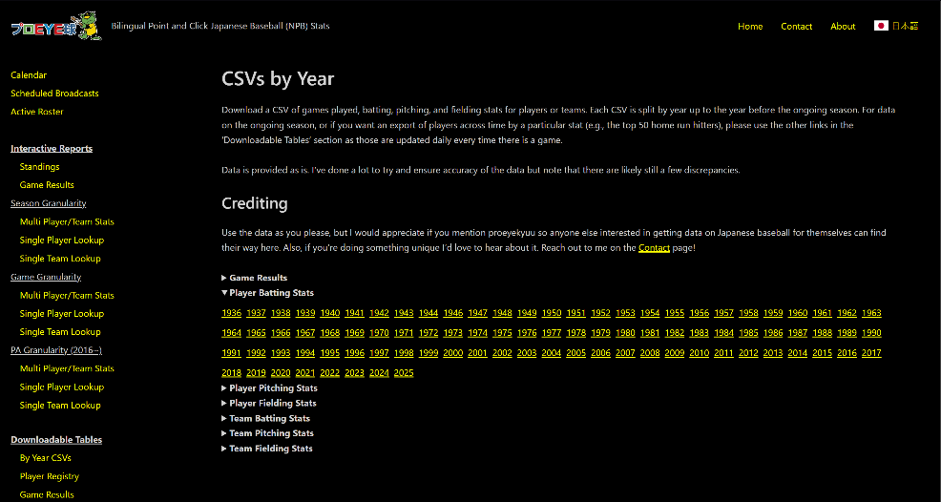

- https://proeyekyuu.com Play by Play
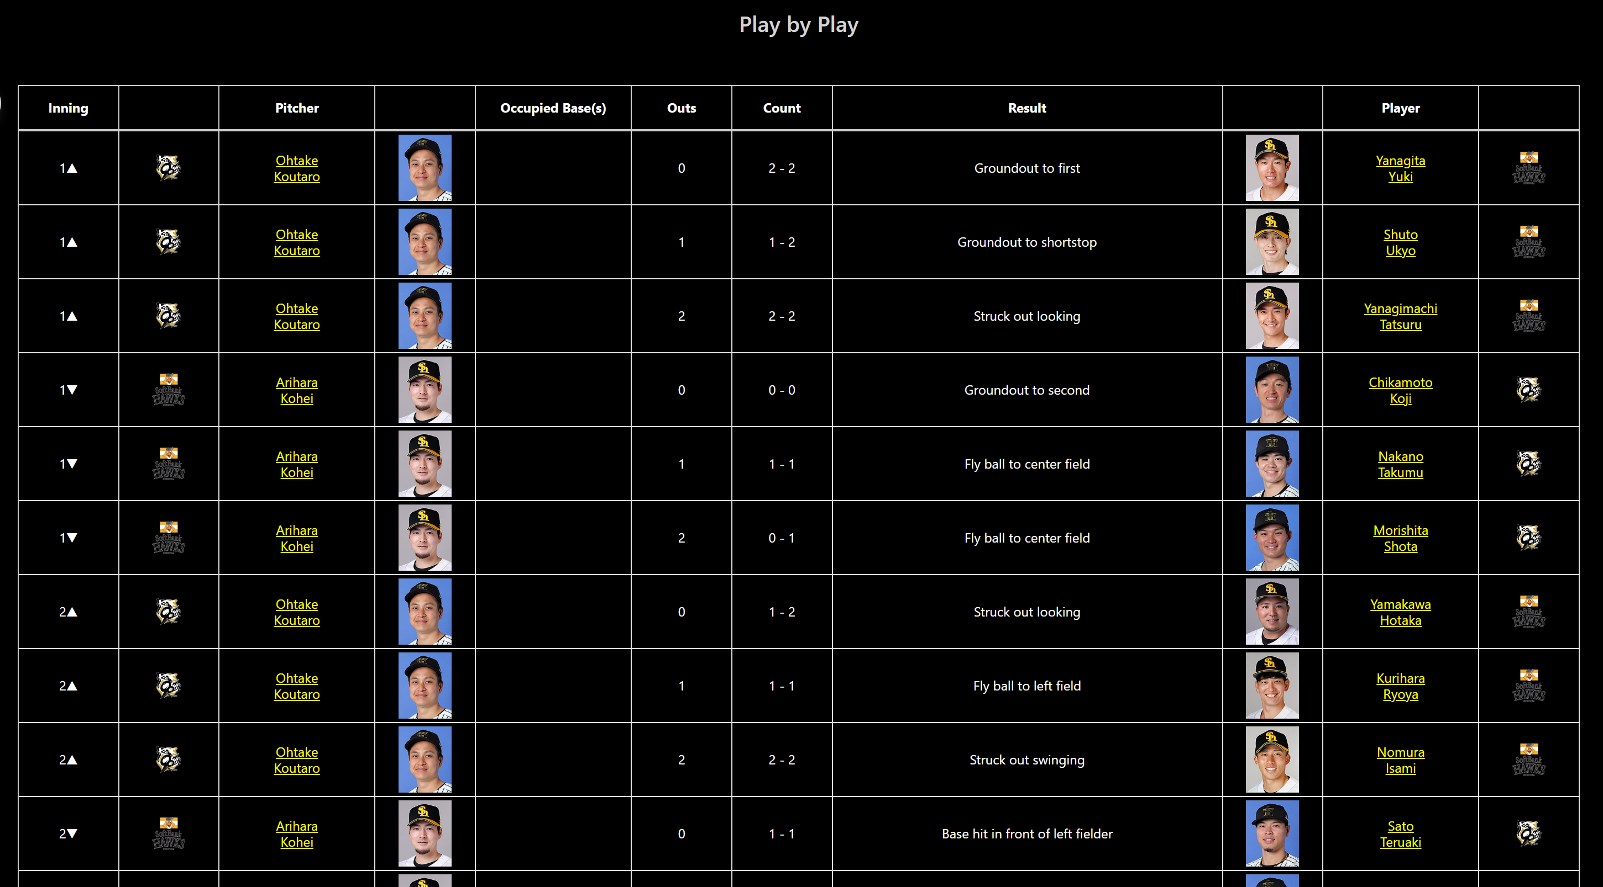

- ServiceTime calculation
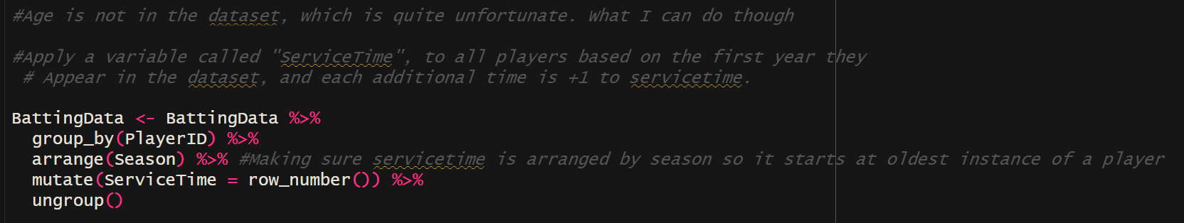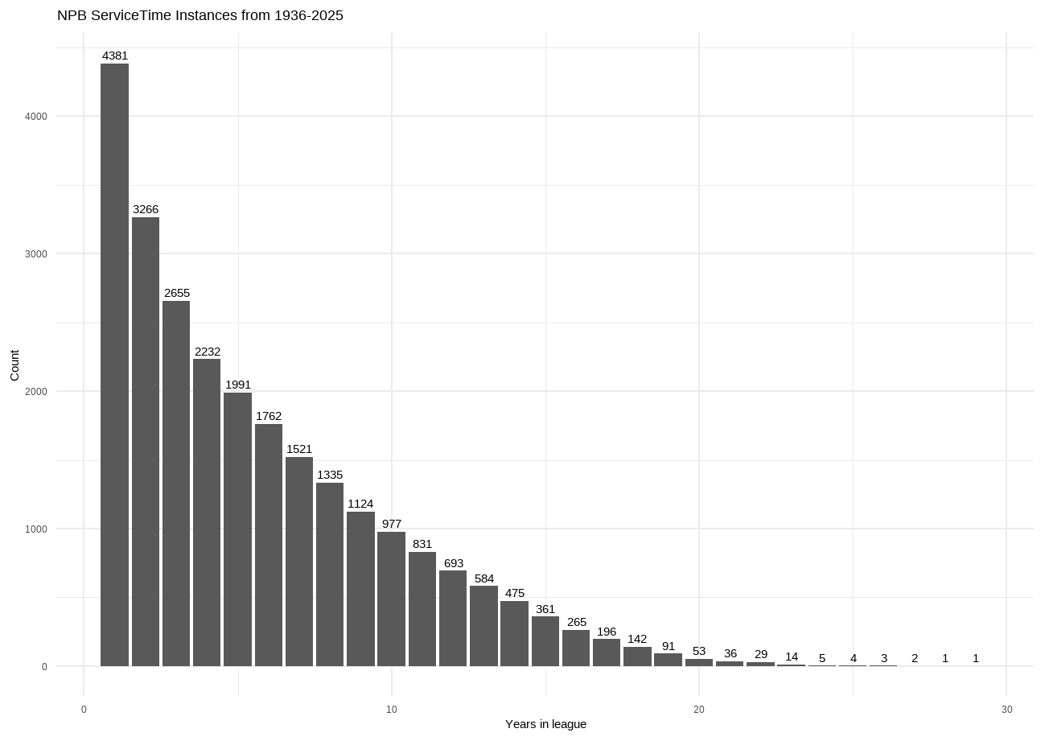
- Pearson Correlation + Column removal
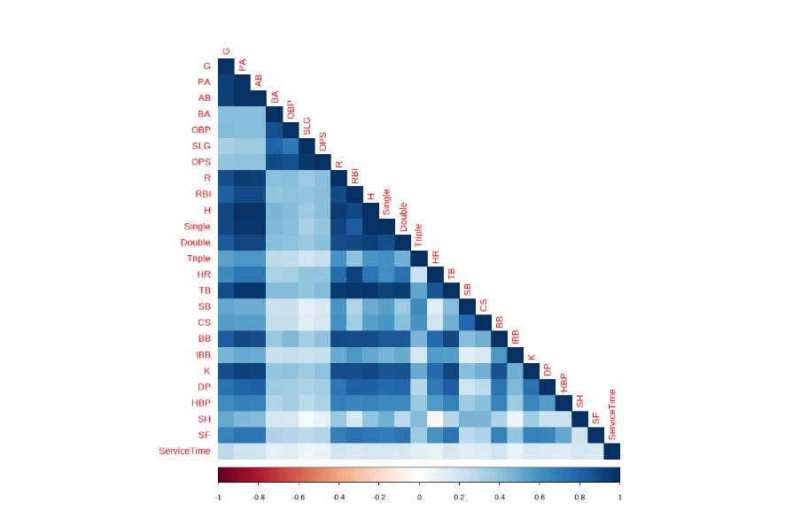
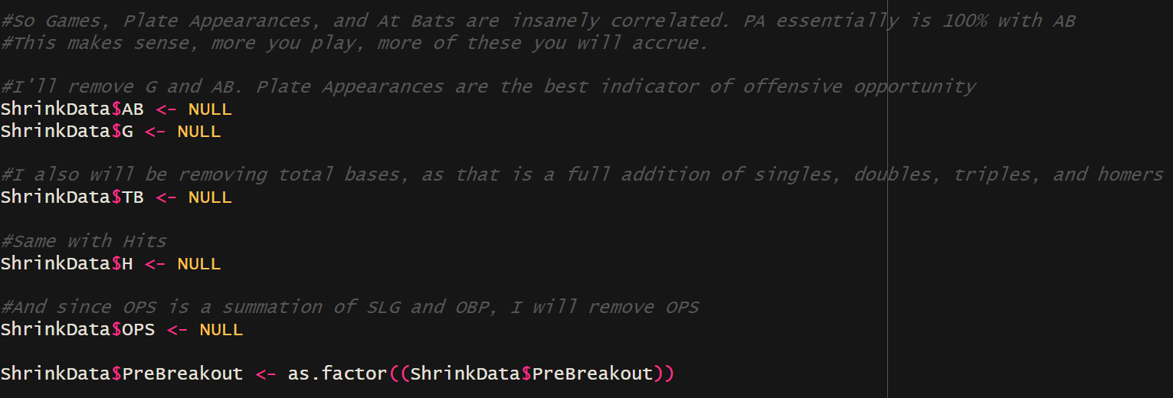
- Removing Data imbalances
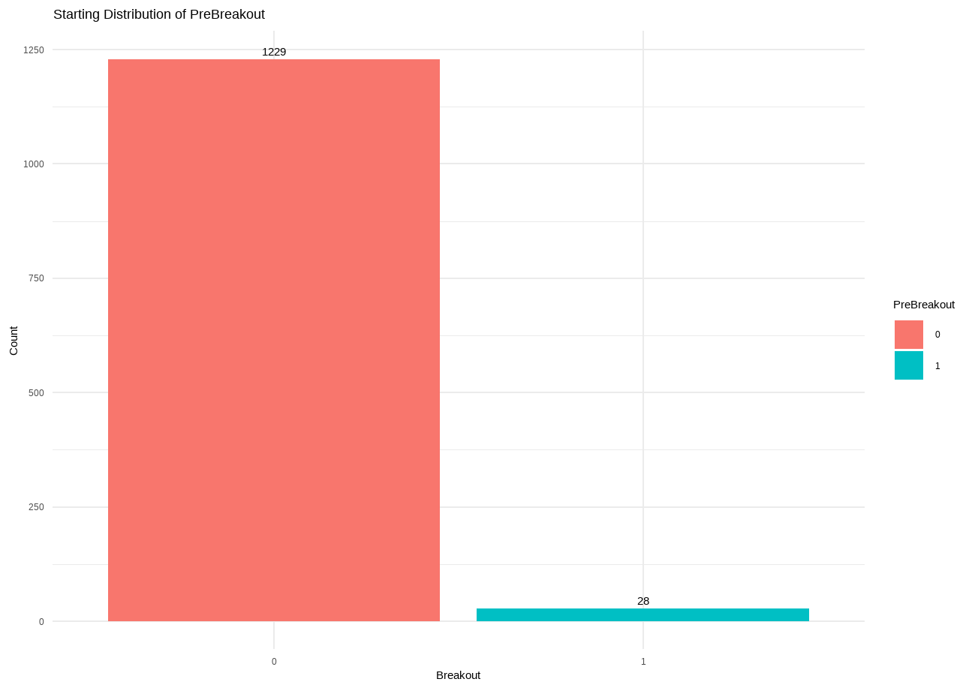
----------------------- Classification Tree Parameters ------------------------------------------------
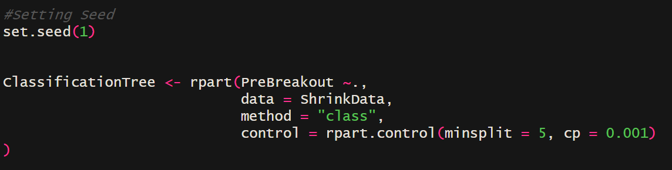
----------------------- Classification Tree Output ------------------------------------------------

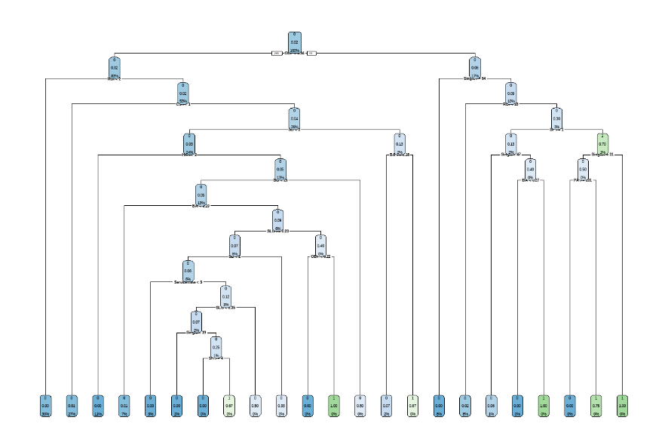
----------------------- Distribution After Classification Tree -----------------------------------------------
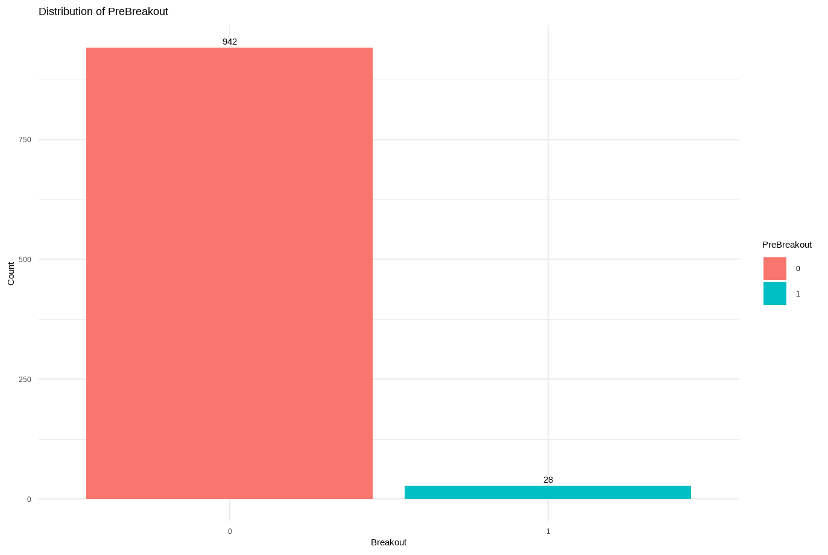

----------------- ROSE then run to get 1500 total data points, 40% positive ----------------------------

---------------------------------------------- ROSE output ----------------------------------------------------
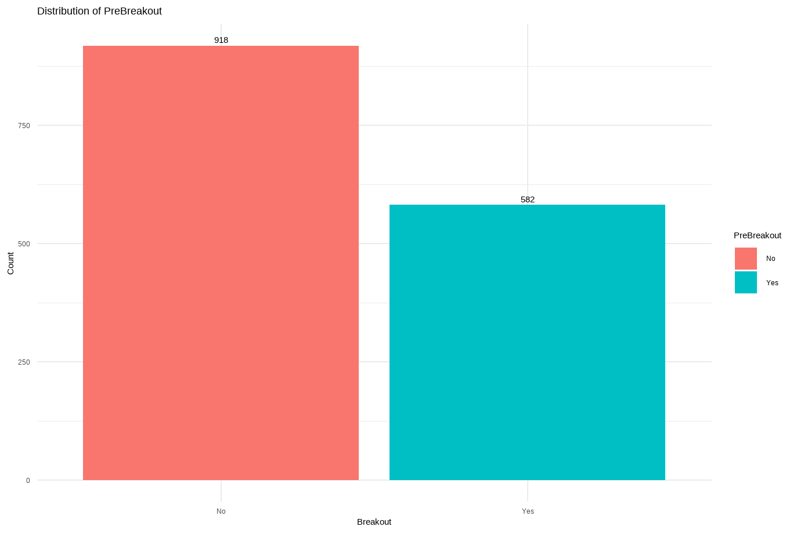

- KNN Model
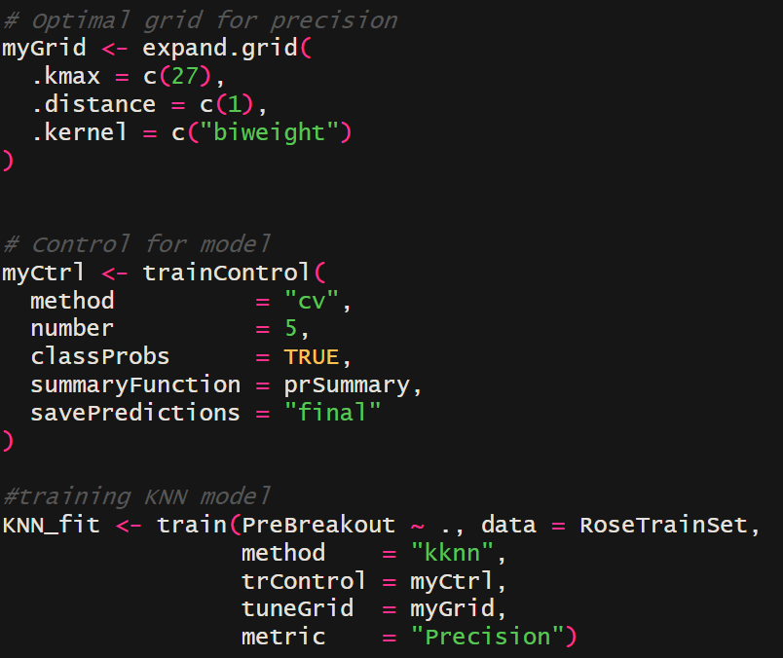

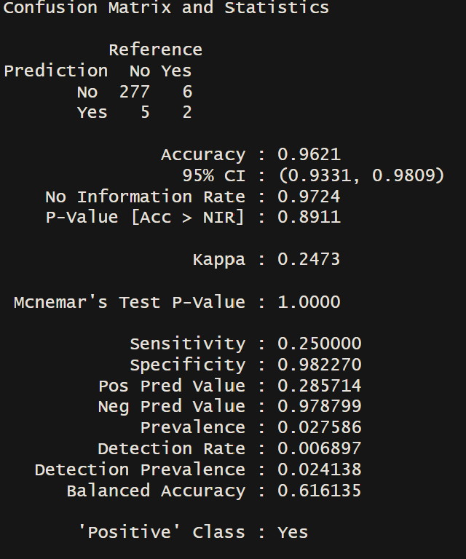
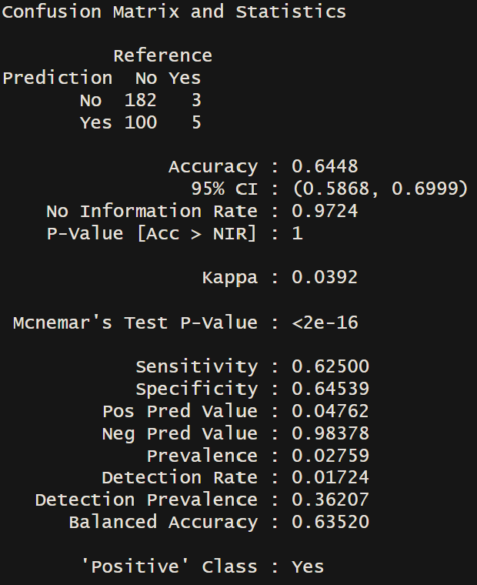
- KNN Model Confusion Matrices
Base KNN Model
Probability KNN Model (90% Threshold)

- Gains Table
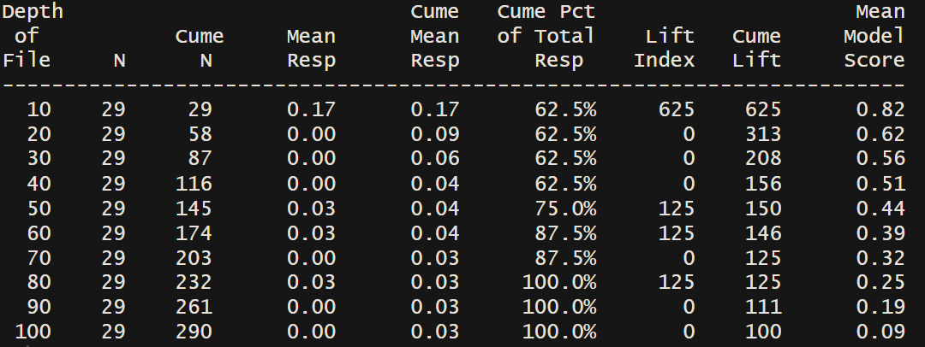
- Cumulative Lift Chart
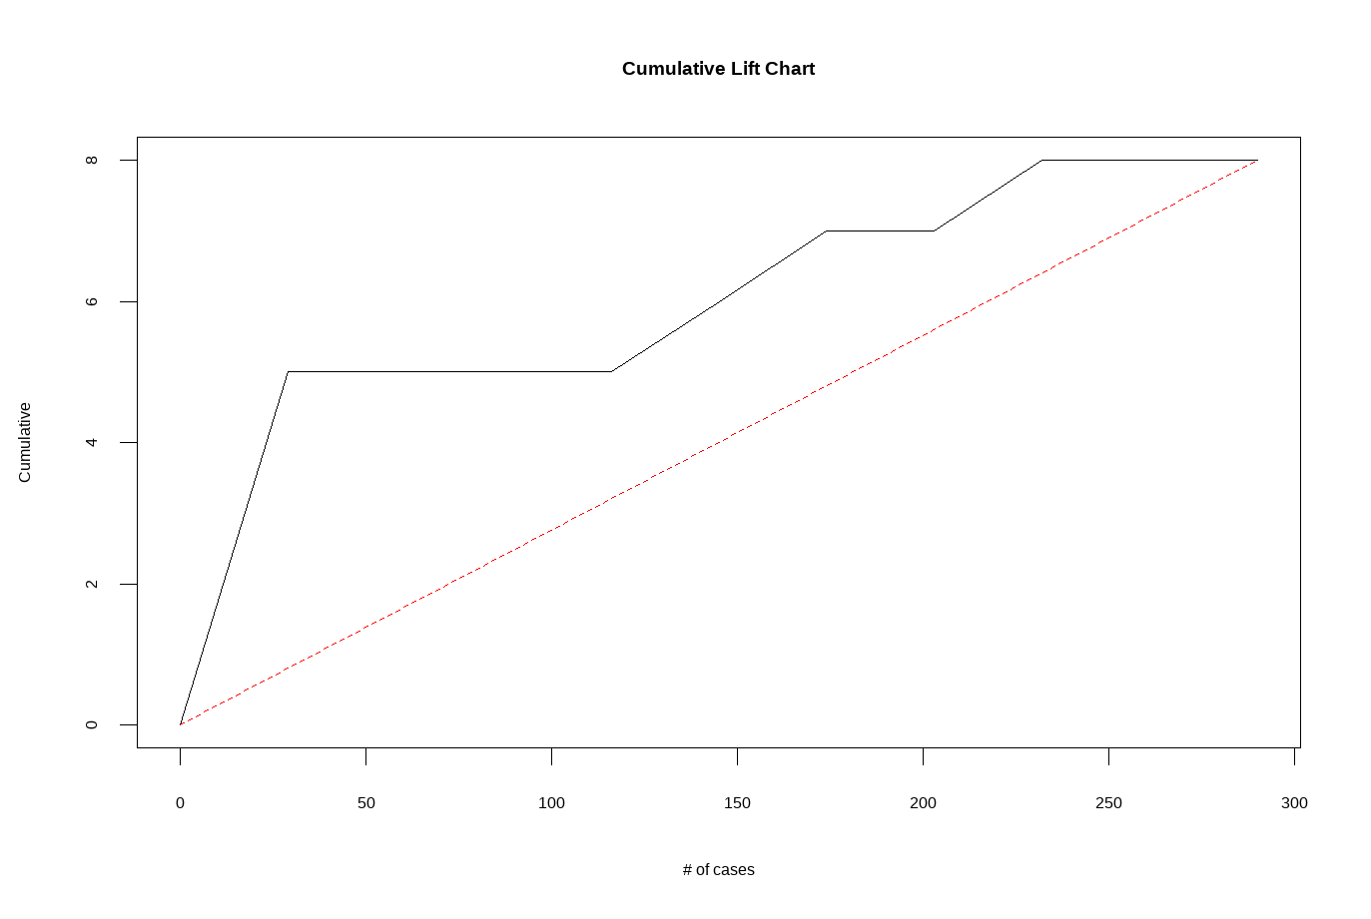
- Decile-Wise Lift Chart
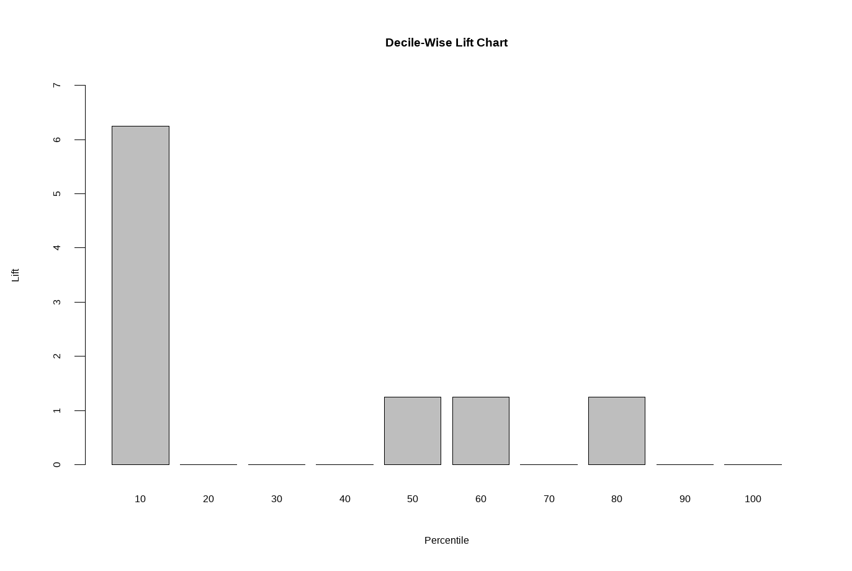

- AUC ROC Curve
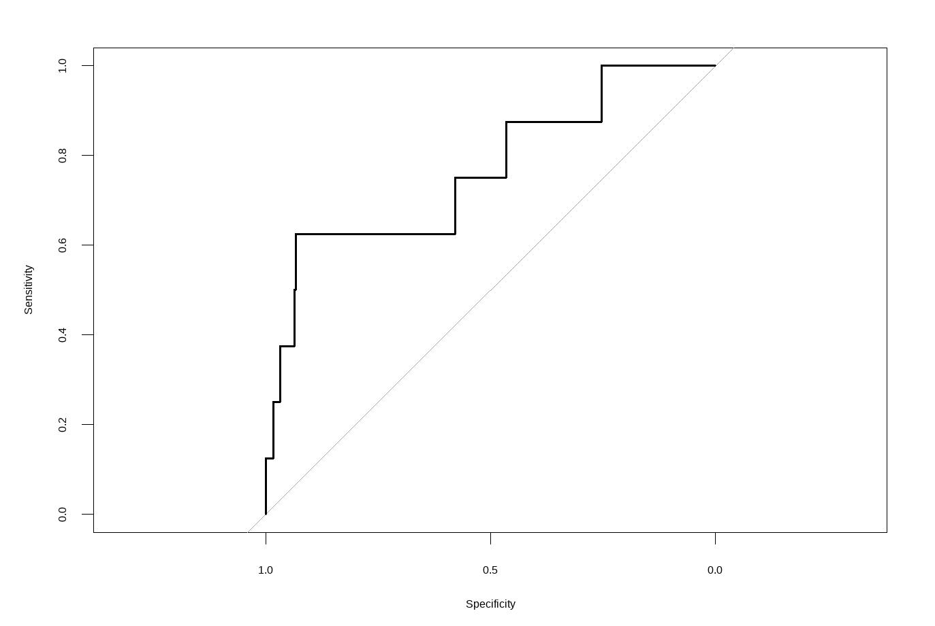
- Model output of Breakout Players (Pre Interpretation)
